25.64: a) 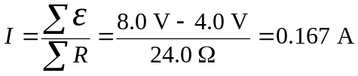
b) The terminal voltage is

c) Adding another battery at point d in the opposite sense to the 8.0 V battery:

